

**Data Science Fundamentals**

Year 1 (2022/23), Semester 1

**SCHOOL OF INFOCOMM TECHNOLOGY**

Diploma in Cyber Security & Forensics

Diploma in Data Science

Diploma in Immersive Media

Diploma in Information Technology

Common ICT Programme

**ASSIGNMENT**

|  |  |
| --- | --- |
| **Tutor & Tutorial Group:** | **Tutor**: Yee Lay Tan  **Tutorial Group**: P14 |
| **Team Leader:** | Huang Wen (S10241971) |
| **Students’ Name/Number:** | Ma Cheng Ze Ryan (S10242111)  Huang Wen (S10241971)  Vishwa  Neron  Ang Yi Yang(S10242860) |

**Introduction**

This report will present data in the form of visualizations and a dashboard for each of the 5 stakeholders. It will preface the uses of these visuals for each of the stakeholders through actionable statements. The graphs and charts will be done in Power BI and shown in the form of visuals and dashboards.

The overall objective of this report is to review the overall performance of a given company and see how each field of work contributes to the profits. Our visuals and report will help our stakeholders understand the company better and make better decisions that will lead to an increase in profits. Our report will be specially tailored for each individual stakeholder.

**Stakeholders Background**

**Company CEO**

As the CEO (Chief Executive Officer) of Aurray, a 10-month-old e-commerce company. I am primarily responsible for the efficient running of the business and developing and assessing the company’s business strategy and determining its profitability. Must evaluate the performance of the department or division to ensure that the business is profitable. I will also need to set directions for his staff such as Sales Targets for the Sales Manager and New Customers for the Marketing Manager, to grow the business and identify major market segments for the company to enter.

**Exploratory question:**

1. Questions about the profit, sales and profit margin for the company.
   1. What is the profit and sales for each product type?
   2. What is the profit and sales in various parts of Australia?
   3. What are the total sales, profits and profit margin up to date?
   4. What is the trend for monthly sales and profit? -
2. What is the number of new customers per month?
3. What is the number of orders per month?
4. Which age group is my major customer?
5. What is the average customer spending per order?

**Actionable Statements (Individual: 5 marks)**

As Aurray’s CEO, to perform my job efficiently. I must be capable of fulfilling my primary job responsibilities. Ultimately, as a CEO, I need to monitor the performance of my company. Creating new measures for the company according to its performance and setting direction for my staff to focus in. So that I can ensure that the Aurray is making a profit and maximizing the profit generated.

**Exploratory question:**

1. **What is the profit and sales for each product type?**

Explanation:

This question allows the CEO to know the details of the sales and profit of each type of product details. These details will show the CEO which product is popular and profitable, and which is not. The CEO will understand which product the customer is interested in. Making necessary adjustments and improvements to the product type that has lower sales or coming up with more products for the popular product types. For example, if the jacket has the lowest sale, I can work with purchasing manager to find a cheaper jacket supplier that offers the same quality to reduce the selling price of the jacket. This can allow Aurray to attract more customers to buy the cheaper jackets.

1. **What is the profit and sales in various parts of Australia?**

Explanation:

This question allows the CEO to know the sales and profit in various parts of Australia. This information will show which part of Australia has high sales and profit and which has low sales and profit. The CEO will understand which part of Australia has little interest in their product and find reasons why they have low interest in Aurray’s product (Competitors, product not suitable...). Then, the CEO can implement methods to increase sales and profit for each part of Australia separately. For example, the CEO can work with the purchasing manager to find and sell products that are suitable for the people living in Queensland. This will attract people living in Queensland to purchase the new and suitable products sold.

1. **What are the total sales, profits and profit margin up to date?**

Explanation:

This question will allow the CEO to know the overall performance of Aurray for the past ten months and did the performance hit the target set by the company. Then, the CEO will be able to implement new methods and directions for his staff to focus on the future so that Aurray can achieve the target sales, profit and profit margin. Aurray can also set a new target for sales, profit and profit margin for next year based on the information.

1. What is the trend for monthly sales and profit?

Explanation:

This allows the company to know the monthly trend of the performance of the company. This information will show the sales and profit for each month. The CEO will understand the buying trend of Australians and adjust the company stocks according to them. For example, the CEO can work with the inventory planner to adjust the products stored in the storage. For months that have high sales, we can store more stocks in the inventory or rent new storage to store more products. This can increase the sales of products for months that have high sales as the company would not have to worry about running out of stock.

1. **What is the number of new customers per month?**

Explanation:

This shows the number of new customers per month. Customer growth is also another measure of the company's performance. Having more customers brings benefits such as an increase in sales, brand awareness and feedback for improvement. More customers can increase profit and feedback on products. This feedback helps Aurray to know where the product and service is lacking and implement ways to improve the product and service quality. Ultimately, increasing profit for Aurray. Hence, it is important to monitor Aurray new customers.

1. **What is the number of orders per month?**

Explanation:

To show the company when are the months that the company has a high number of orders. This allows the company to adjust before the month such as increasing the stock in inventory and hiring more workers.

1. **Which age group is my major customer?**

Explanation:

To show the company which age group is our major customer. Then, the company will adjust strategies according to the data. For example, if the elderly has the least number of sales, The CEO can work with purchasing manager to purchase products that are suitable for the elderly. This will increase the sales for the company as more elderly people will be attracted to purchase products suitable for the elderly. After all, it is cheaper to retain customers compared to finding a new one.

1. **What is the average customer spending per order?**

Explanation:

To show the company the average spending of a customer, to see whether our product is too expensive for the customers. Then, the company can adjust the price of the products closer to these values. Allowing more customers to be able to afford our product and increasing our sales of the product.

**Data Analysis and Visualization (Individual: 20 marks)**

* This is a visual showing the sales for each product type in the various state of Australia.

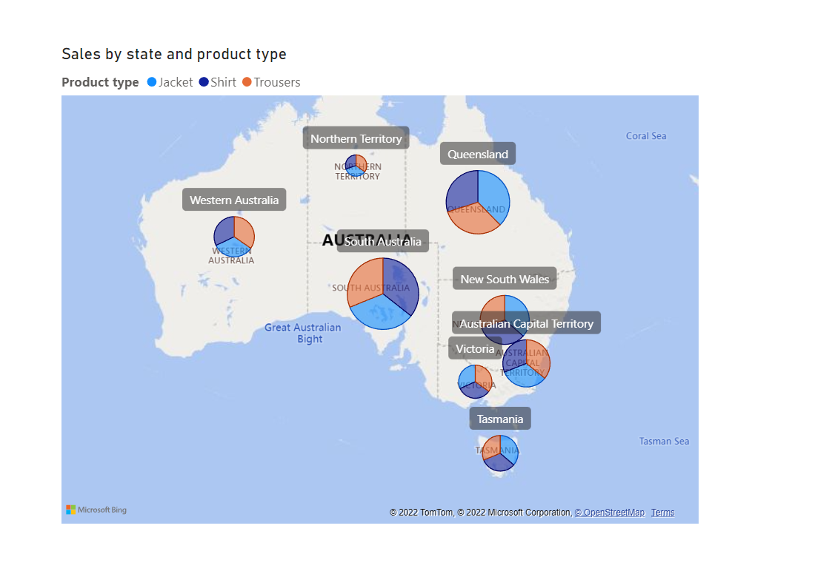

This visual is important as it shows the CEO the sales of different product types in the different states of Australia. The size of the bubble showed the number of sales, the larger it is the higher the sales and vice versa. This allows the CEO to have a closer view of the sales generated by each state. The company can find out the reason behind the popularity of products in various states. Then implementing measures for the company to increase sales for different states. Such as releasing products that are popular in the state to increase profit generated by the state, having cheaper delivery fee for state that has less sales.

* This visual shows the sales and profit of the company in different months.

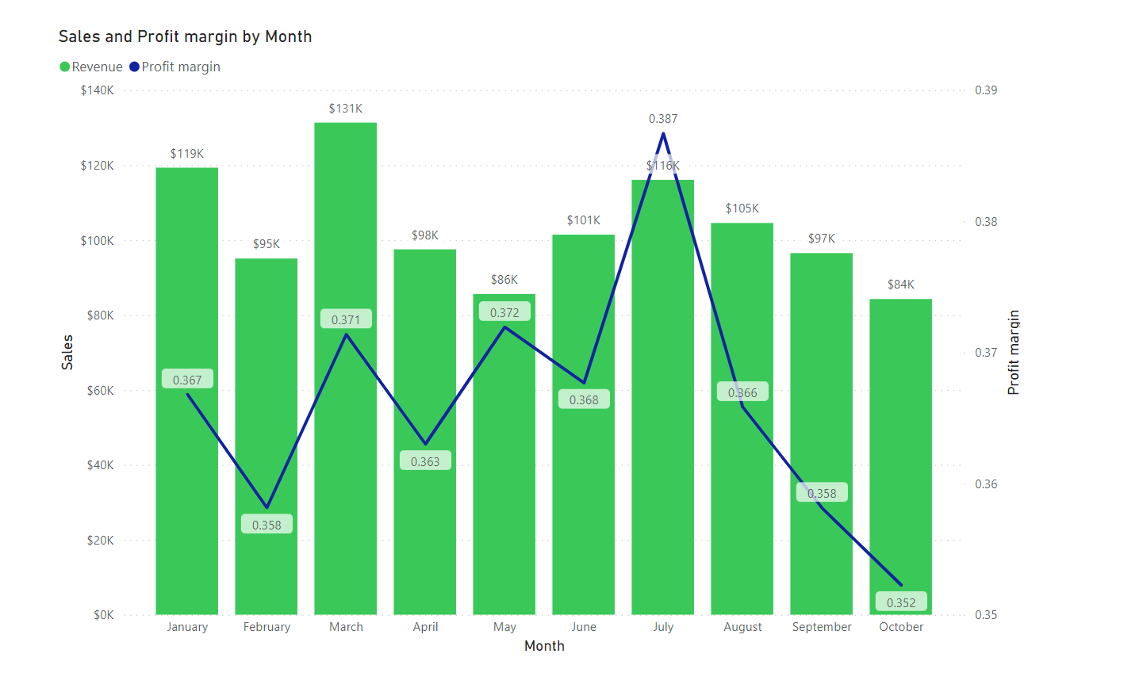

This visual is important as it shows the monthly trend of sales and profit margin of Aurray. CEO can adjust many things based on this graph. For example, the sale is highest in March. The CEO can work with the inventory planner to store more products in the storage in February, preparing Aurray for March.

* This visual shows the profit of jackets, shirts and trousers separately.

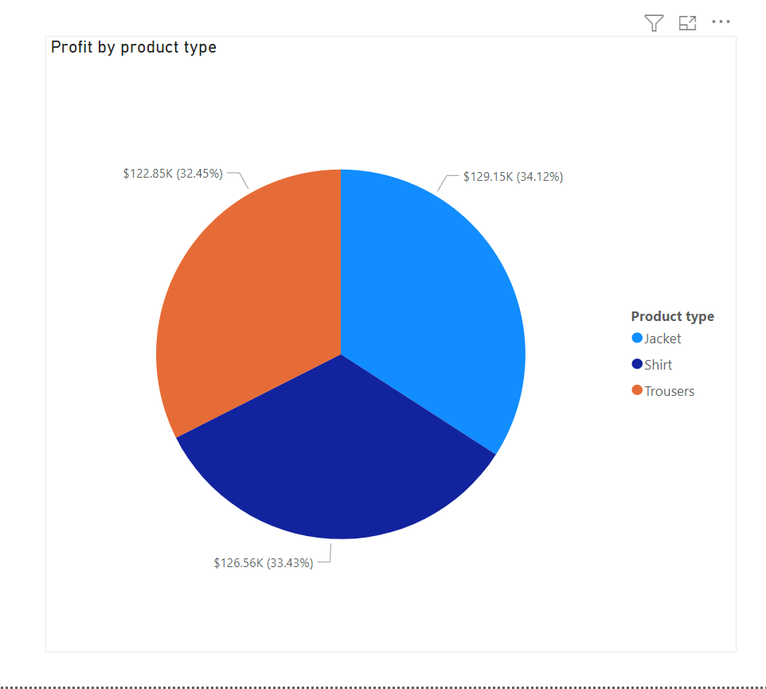

This visual shows the profit generated by different product types. The CEO can create and implement strategies for different product types based on this pie chart. In this case, where the profit generated is almost the same, the CEO can work with the purchasing manager to find a cheaper supplier that supplies the same product quality to reduce the cost and increase the profit made.

* This shows the number of orders for each month.

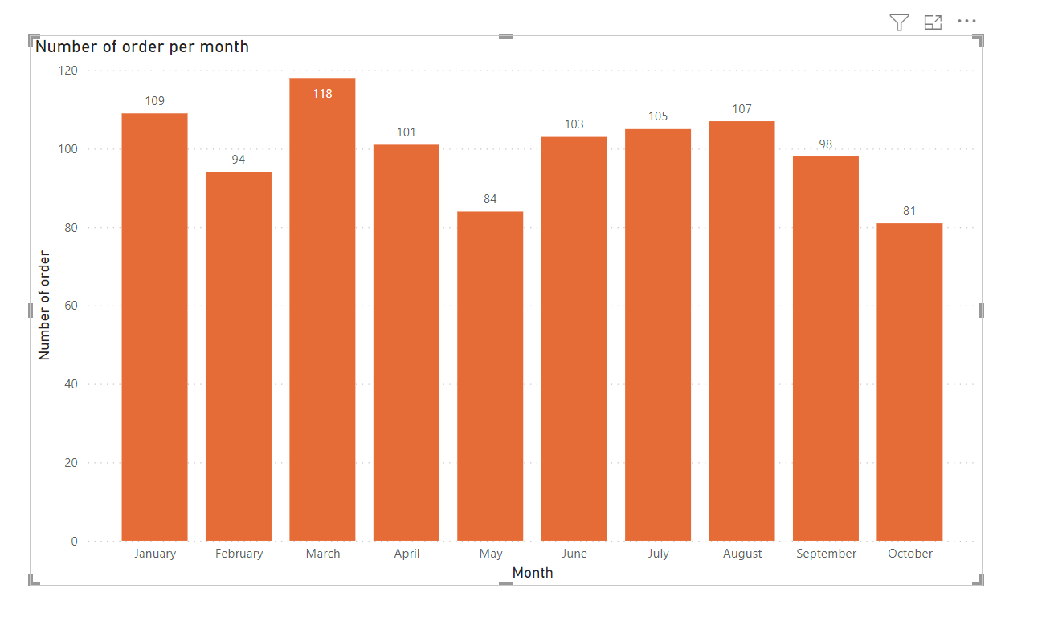

This allows the CEO to adjust the company based on the visual. The CEO can adjust the number of stocks in the inventory. Ensure that the company will have enough products to sell for months that have high number of orders. This visual can monitor the number of orders per month. It is also an indicator of company performance. This allows the CEO to see the shopping month for Australians and study when they will purchase items.

* This visual shows the number of new customers per month.

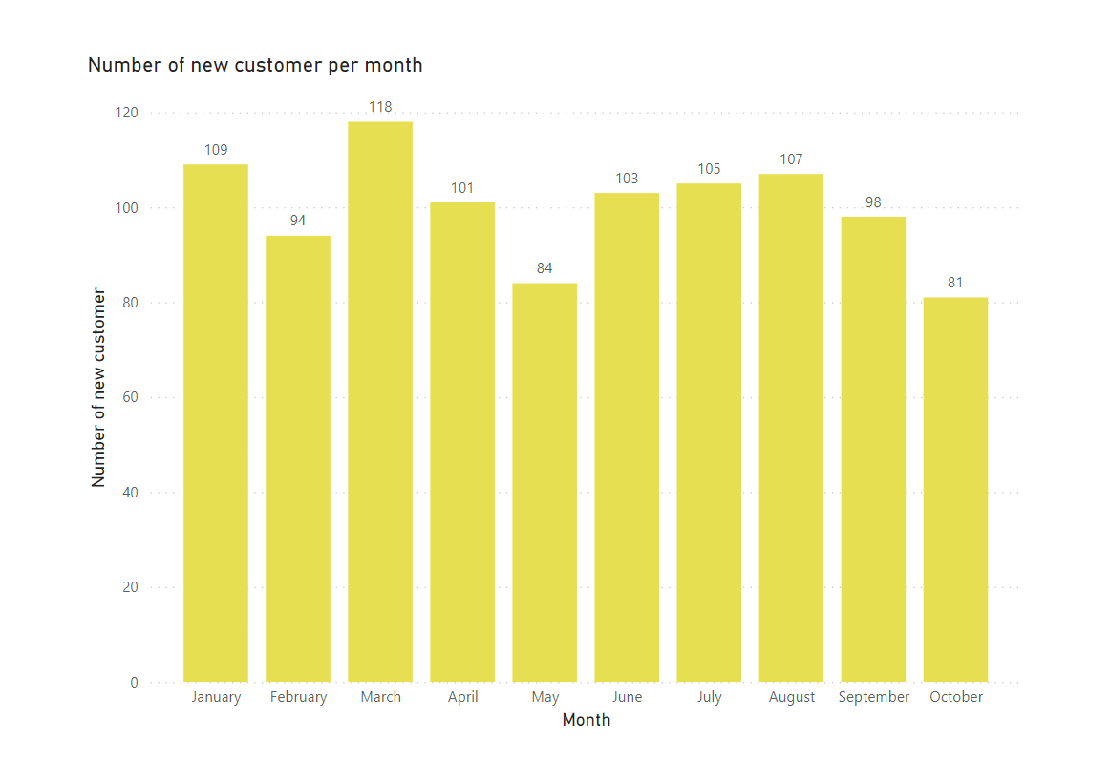

This shows the number of new customers. This is important as new customers can increase sales of the company, brand awareness and brand improvement. More customers will improve the sales of Aurray, ultimately increasing the profit earned. It can also help the potential customer to recognize the brand, increasing brand awareness and sales. Lastly, more customers can give useful feedback to Aurray to improve the quality of the product, attracting more customers to buy. Hence, keeping track of new customers is important as new customers are useful and valuable for Aurray. The reduction of it can be an alarm for the CEO of negative situations such as the rise of competitors.

* This visual shows the sales of different age groups.

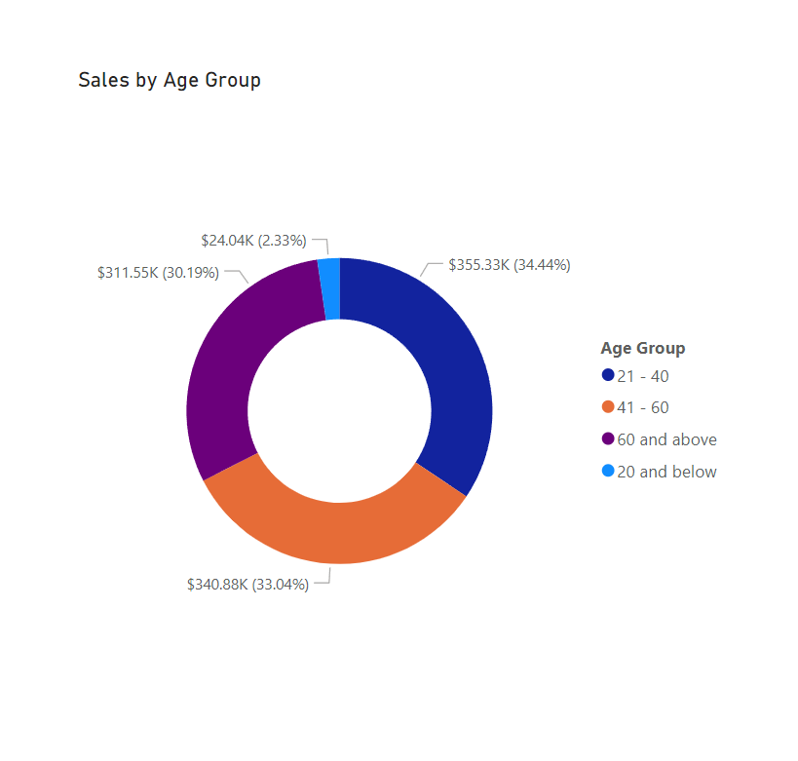

This allows the CEO to know which age group is the major customer. So that the CEO can adjust the marketing strategy and other related products that are suitable for the major group of customers. So that it can increase the sales and profit of major customer groups. The CEO can work with his staff to come up with products that are suitable for the 20 and below, which is the smallest group of customers. Finding ways to increase the sales and profit for 20 and below and retain this group of customers. After all, it is cheaper to retain customers compared to finding a new one.

**Dashboard 1**

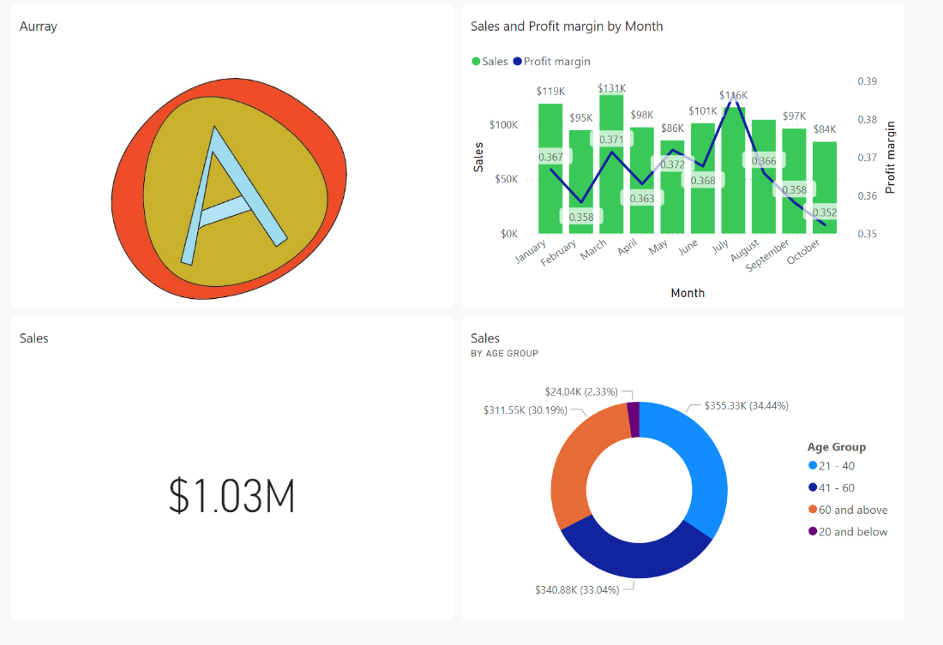

This is my first dashboard. I placed sales and profit margin by months tile and Sales by age group tile as visuals on my dashboard. These two dashboards in very important for my stakeholder (CEO). He needs to know the trend of sales for the company. So that he can make different adjustments based on this data. For example, increasing stocks before the months with the highest sales. Hosting promotions and discounts for products in months that have low sales to boost sales. The CEO also need to know which age group is Aurray’s major customer. This allows the CEO to know which age group to focus on and release products that are suitable for the age group. For example, in the pie chart, below 20 has the least sales. The CEO can work with the purchasing manager to buy products that are suitable for teenagers. This will allow Aurray to boost sales for people under 20 and retain this group of customers. After all, it is cheaper to retain customers compared to finding a new one.

**Dashboard 2**

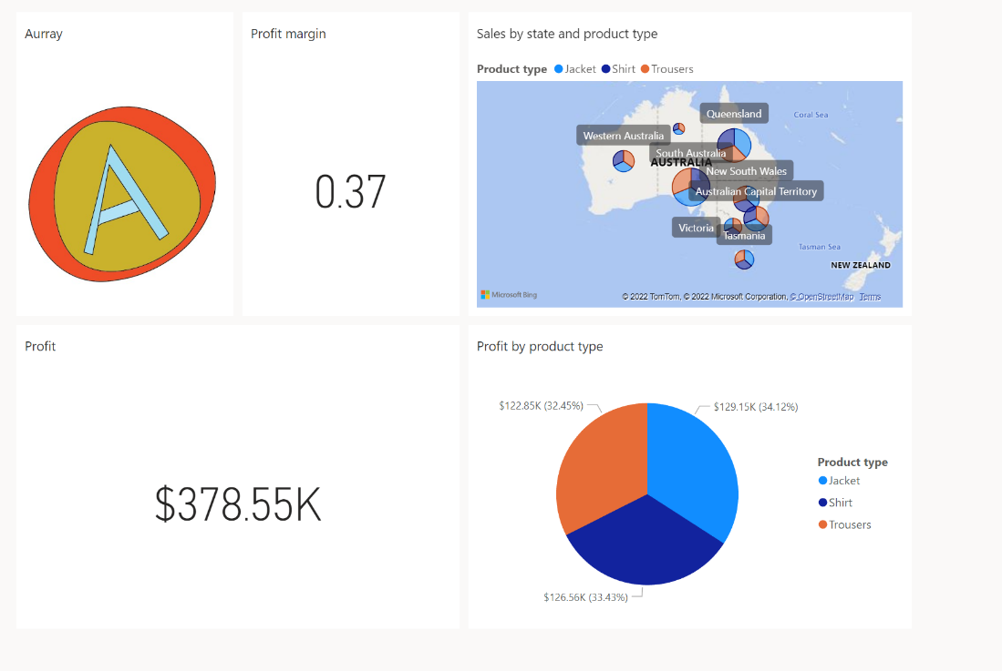

This is my second dashboard. I placed profit for different states and profit for different product types as visuals for my dashboard. Both tiles are important for the CEO. The CEO needs to know the sales of products in different states. This allows the CEO to understand the popularity of products in different states. The CEO then can work with the purchasing manager to find and buy products that have high popularity in the state. On the other hand, the overall profit is important for each product type, and it is important for the CEO. It allows the CEO to assess the profit gained from each product and adjust the strategy used for each product type. This helps the CEO to be able to further increase the profit from the products.

**Sales Manager (Neron)**

**Background**

Sales managers work for the financial well-being of the company by maximising profit margins from their product through minimized expenditure and increased revenue. They bring in repeat customers by forging and retaining good relationships between consumers and the company. Monthly, they devise sales targets and ensure that it is achieved, as well as plan future sales targets according to the company’s monthly performance, and the trends within the company’s revenue and expenditure.

**Possible questions**

-Profit margin - expenditure and revenue throughout the months inclusive of logistics

-No.of sales throughout the months - has it been increasing/decreasing. Determines the reputation of the company

-Which product has a good rep/ which has little  (what does this tell?)

-Customers per month - have they been coming back -determines their satisfaction as well

as our relationship w them

- Do we have repeat customers.

-size of order (trust in quality of product)

-age/city/country  - target audience (has it been achieved?)(do we have a large target audience)

- no. of products per order(what the product is and the quantity of it)

- Which products have resulted in a loss in profits?

**Exploratory questions**

* How has the company’s traction - as seen through the monthly number of sales - been affected over the months?
* How has customer satisfaction with our products been, as seen through the rate of repeat orders throughout the months?
* Which products have resulted in a loss in revenue?
* Among the types of products sold, which has the highest popularity among the consumers.
* Throughout the months, has our profit margin been reaching the target seen through the revenue to expenditure ratio?

Actionable statement:

As a sales manager, I must ensure that I filter out the losses and bring in the profits. The revenue must always be higher than the expenditure. I must also ensure that customers continue with their interest in the company.

**Visualizations**

This line and stacked column chart depict the monthly profit and number of sales, allowing for the sales manager to view the trends of the company’s economic well-being throughout the months. The profit and number of sales are charted together allowing for easy comparison between the two aspects, proving whether a common trend - such as increased sales leading to an increase in profit – exists. Thus, allowing the sales manager to see whether the two aspects live in conjuncture with one another. And thus seeing whether focus put on the number of sales is beneficial. In cases where there is no profit for each product sold, the sales manager can first aim to adjust expenditure and product costs rather than simply aim for an increase in the number of sales. This chart helps the sales manager zoom into aspects that might have resulted in the loss of profit for the specific months as well as notice the aspects within the month that contributed to the increase in sales and profit. Therefore, allows for further pushing of the company’s economic profits through the relevant study of the months.

As a sales manager oversees maintaining good relations between the company and its clients, he/she has to have a rough handle over the success of past strategies aimed at retaining clients This visualization charts the number of customers who made a certain number of orders over the past 10 months allows for the sales manager to view the number of clients who have continued with patronizing the company. This helps the sales manager keep a record of the number of relations forged as well as view whether its attempts to do so have been successful. With this information, future sales strategies can be altered accordingly, bringing, and retaining more long-term customers.

The charts charting the product types, names, and colors according to respective months allow for the sales manager to identify trends between products being sold as well as the popularity of each product, helping the sales manager to be able to pinpoint specific products or trends that are rising in popularity. Therefore, the sales manager will always be informed of the emerging markets and market shifts, in turn predicting future sales prospects and setting monthly or seasonal profit goals accordingly. Based on product types, the profit margin can also be seen for the various products by name, allowing the sales manager to ensure that there is no loss in revenue suffered by the company, or if there was, plan out accordingly to mitigate losses.

By identifying the products contributing to a loss in revenue, the sales manager can string the common trends between the varying products and ensure that these trends are not applicable to future products made by the company. This helps ensure that a profit is made in every product sold and that the company benefits financially with every transaction.

The dashboard contains the number of sales and profits, number of orders, loss in revenue as well as the popularity of the product types, allowing for the sales manager to plan accordingly, increasing the company’s revenue through prevention of losses and increase in profits.

**Marketing Manager (Ang Yi Yang)**

***Stakeholder Background***

As a marketing manager, I am in charge of processing data based on our sales and deciding which market the company is most profitable in as well as a potential market that we can expand our company into. Marketing managers also have to select the best way to market to different age groups etc after taking into account the products that we have.

***Exploratory Questions***

1. What is the is the product that I should consider marketing more heavily?

2. What market can we consider entering?

3. What is the target age group we should be marketing towards?

4. At what periods of the year are certain products more marketable?

5. What new markets should we enter?

5. What is the highest selling product that the marketing strategy should be centered around?

***Actionable Statement***

As the organization's marketing manager, I have to come up with a marketing strategy that is calculated and maximises profit for the company after taking into accoun the target audience of our company as well as the current market of apparels in Australia

***Visualisations***

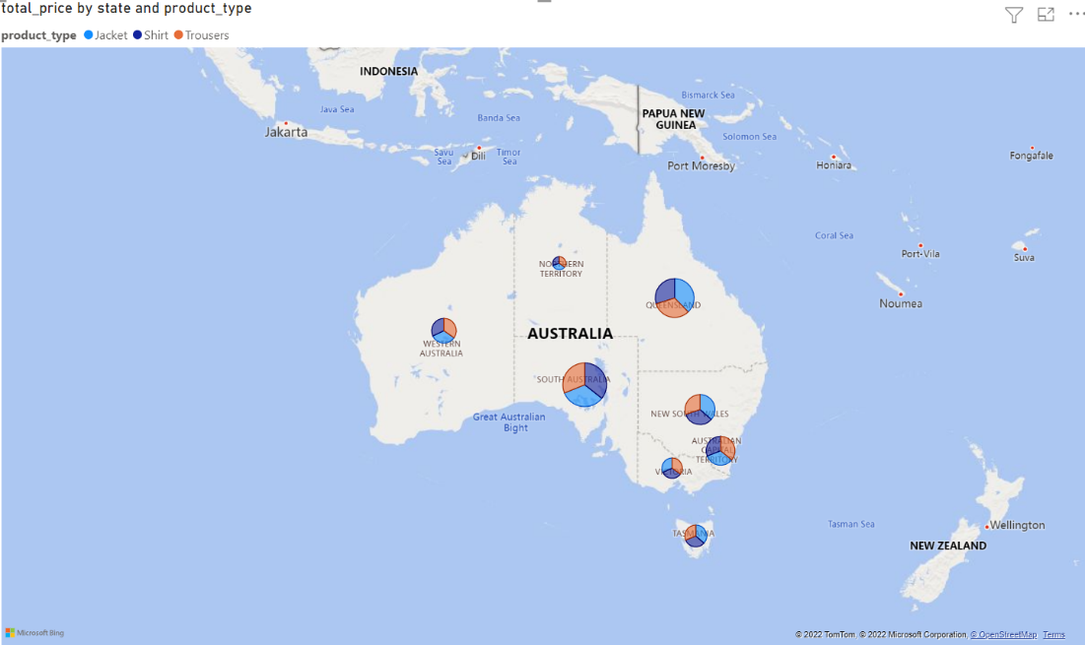

With this map visual, the different markets are separated by different states that Aurray has seen sales in Australia. This allows the marketing manager to have a clear view of the different markets the company is in and accurately determine the biggest market by total price; South Australia. Furthermore, breakdowns of the different product types; light blue as jacket, dark blue as shirts and orange as trousers, can be seen in conjunction with the size of the market, depicted by the size of the bubbles in order to give the marketing manager a closer view of each individual market in order to understand the product market within each individual state. This allows the marketing manager to be able to grasp the highest earnings market and have a calculated marketing strategy to market it to the consumers, making it more effective, which in turn draws in more customers to make bigger profits.

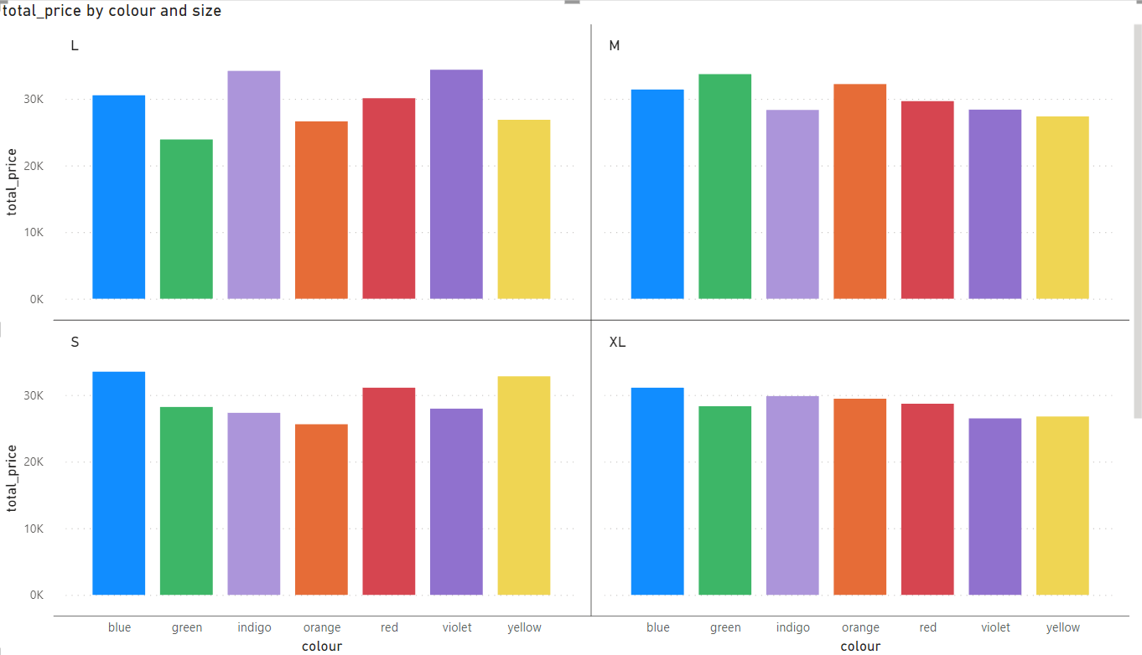

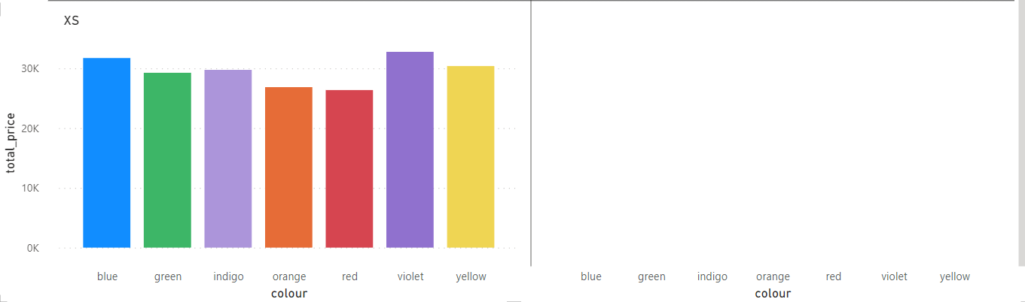

With this total price by colour stacked column chart with small multiples by sizes, the marketing manager can see the different coloured products by total price whilst keeping in mind the different sizes. This allows the marketing manager to know which sizes and their respective colours have the most sales and market accordingly. For example, in the case of products in the L size, violet products have the highest sales with $34372 in total, allowing the marketing manager to know that violet products have the highest sales and can market it accordingly, for example having sales of violet products with discounts to attract more customers to it. Similarly, using the graph, the marketing manager can also find out the sizes of products with the most sales, being the M size with a sale of $211018, hence having a discount on M sizes. Another way this graph could be useful would be to see the product with the lowest sales and increase its price since the market for it is lower and considering it has a lower demand.

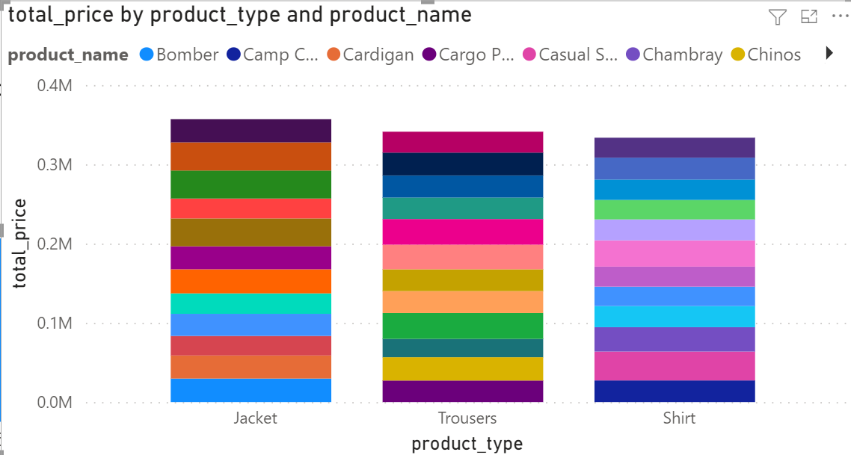

With this stacked column graph of total price by product type and name, the marketing manager can figure out the sales of the different products and their individual breakdowns based on the product name, allowing the marketing manager to know the sales of each individual product available and coming up with a marketing plan around the highest selling product. For example, assuming linen was the highest selling product, the company could have a summer sale during summer season and have linen products go on sale together with other summer related products like polo products.

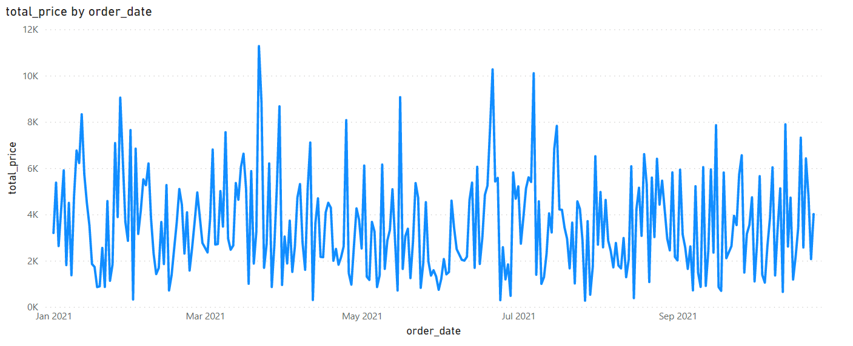

With this line chart, the marketing manager can get a rough view of sales over time. Using this chart, marketing managers can set up marketing campaigns during specific time periods that have the most sales, such as May to July, in which a marketing campaign could be centered around this time period, winter, thus having a winter sale to attract more customers.

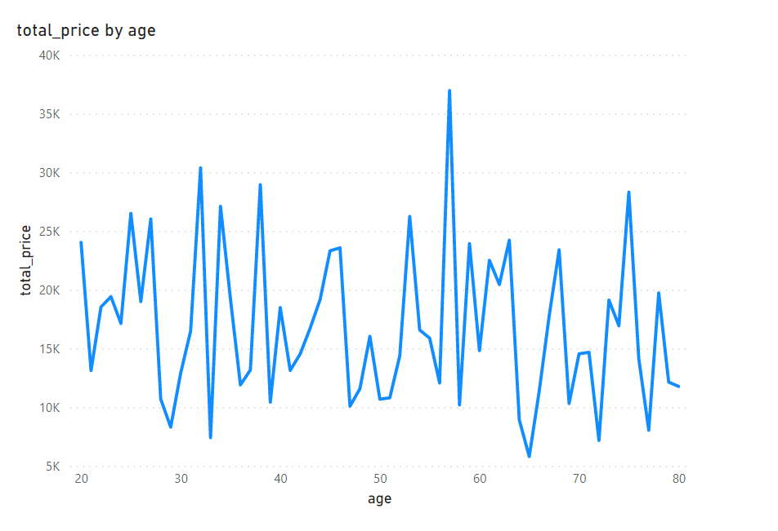

With this line chart of total price by age, the marketing manager can have a clear grasp of the demographic of the consumers of the company, which in this case is around the age of 50 to 60, with 57 having the highest sales, this information can then be used to have a marketing strategy centered around this age group, in which the company could have more products that are more well-liked by this age group. Additionally, the company could celebrate Father and Mother's Day with exclusive sales on these occasions to target the 50–60 age group which has been doing the best whilst also trying to enter the market of the age group of 40-50 which has not been performing well.

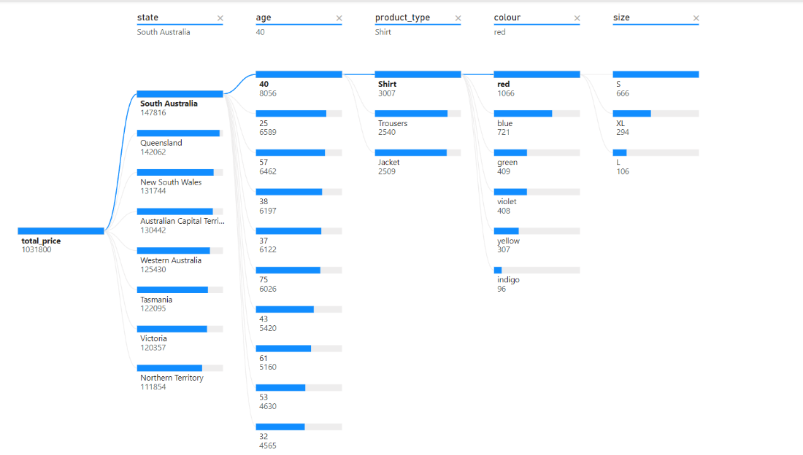

With this decomposition tree visual, the marketing manager can breakdown the individual markets by state, age, product type, colour and size. This allows the marketing manager to have precise data on each state in order to have multiple marketing plans for each state that is catered to each individual state’s market. This is especially useful as the marketing strategy will be able to attract a specific target audience to expand into the market that is currently the biggest in the particular state. Having a marketing strategy for each state also allows for maximised profit since having a general marketing strategy will not always work for all the different markets, for example, each state has a different age group market and if the marketing plan was skewered towards those age 30 and below, the market of those aged 30 and above would be lost in states where the majority of consumers are 30 and above.

**Dashboard**

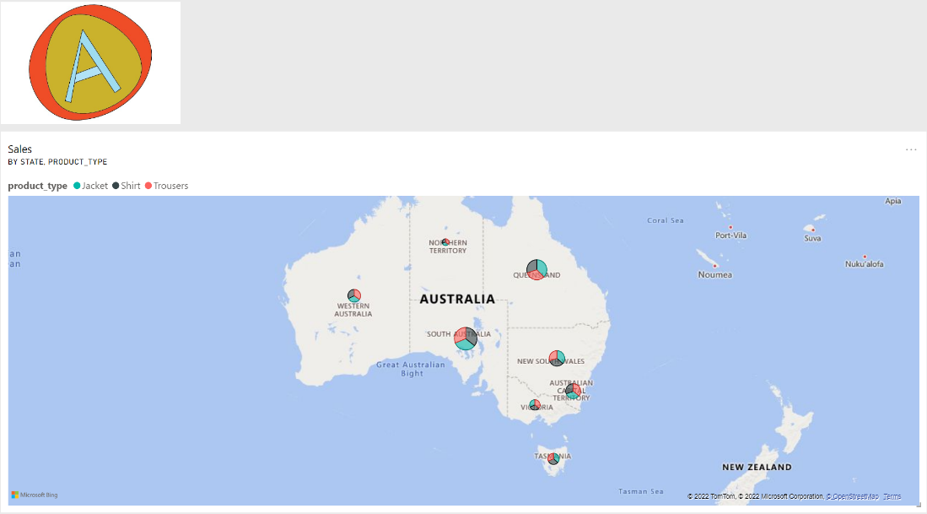

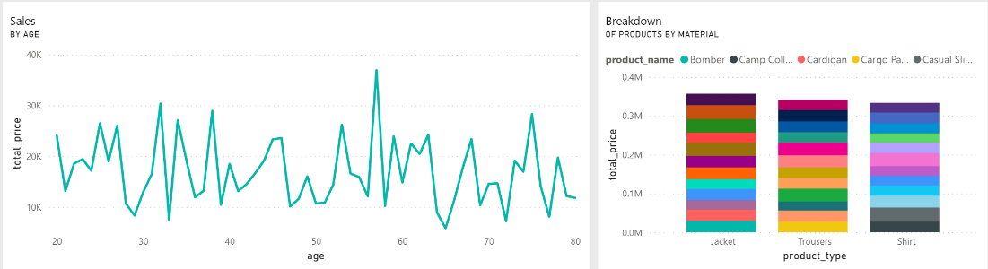

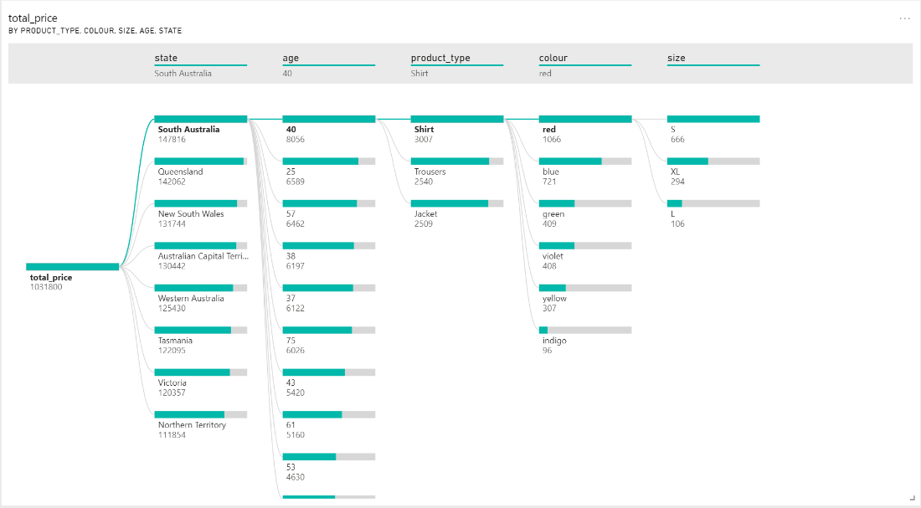

The dashboard includes the map, line chart, stacked column graph and decomposition tree, allowing the marketing manager to have the breakdowns of different sales in order to make an informed strategy plan that will allow the company to make a profit.

**Purchasing Manager / Inventory Planner (Ryan Ma)**

***Stakeholder Background***

As an inventory planner, I am required to assist my company, Aurray, to develop and manage the inventory plans, ensuring that my organization has sufficient resources ready to pack customers' orders. As a purchasing manager, I am required to purchase the different products Aurray sells from the suppliers, determining the specific quantity I should purchase for each product.

***Assumptions***

1. I can assume that for products of the same material, it will be distributed by only 1 supplier, since all the prices of the same material are the same. With this, I can assume that the quality of the products of the same material are the same. (Example: Oxford Cloth products are distributed by 1 supplier only, as the selling price is fixed at $114, having the same quality.)
2. I can assume that the warehouse, where all the products are stored at, is organized based on the product name (Example: There will be storage units and shelves to store each product name respectively – 1 storage unit storing Oxford Cloth products, 1 storage unit storing jogger products, and so on)
3. I can assume that the purchasing of items is based on a yearly basis, as the greatest number of products sold is 24, and the lowest stock-in-hand is 40. Furthermore, buying items in a huge bulk will be more convenient for the company as well.

***Exploratory Questions***

1. Which products have the highest demand during the 10-month operation period for each month?

2. For the specific type of material (Product Name), which color has the best sales?

3. For the specific type of product (Material and Color), which sizes are the highest in demand?

4. What are the products that I should reduce supply intake in order to minimize losses and space in my warehouse?

5. What is the number of items I should purchase for each product to ensure that it maintains above minimum level based on demand levels?

6. What products should I increase my inventory space for according to demands for each product?

7. What specific products are the more profitable ones based on the total quantity sold?

***Actionable Statement***

1. The purchasing manager/inventory planner may require a visualisation to help to determine the products that are selling the best (most popular), which will allow them to make adjustments to the warehouse inventory level and space, and decide on the product quantity that should be purchased based on the demand of the product.

2 & 3. The purchasing manager/inventory planner may need to determine which color is the highest in demand to meet the customers’ needs, as well as the specific size for each respective color.

4. The purchasing manager require a visualisation to determine what products he/she should buy fewer of to ensure that there are minimum losses for the company, as there may be slow moving products, which may result in a loss for the company. The inventory manager also requires a visualization to determine the items that are least sold to reduce unnecessary space being occupied and overshoot inventory levels, not being able to bring in new products.

5. Purchasing manager/inventory planner may need a visual to find out which product type they should increase or decrease minimum levels for.

6. Purchasing manager/inventory planner needs a visual to find out which products they should purchase more of and which products to increase inventory space for, ultimately increasing sales volume, increasing sales revenue at the end of the day.

7. The purchasing manager/inventory planner needs a visual to determine which products are the more profitable ones to maximize profits for the company by determining the profits of the products during the 10-month operation period.

***Visualisations***

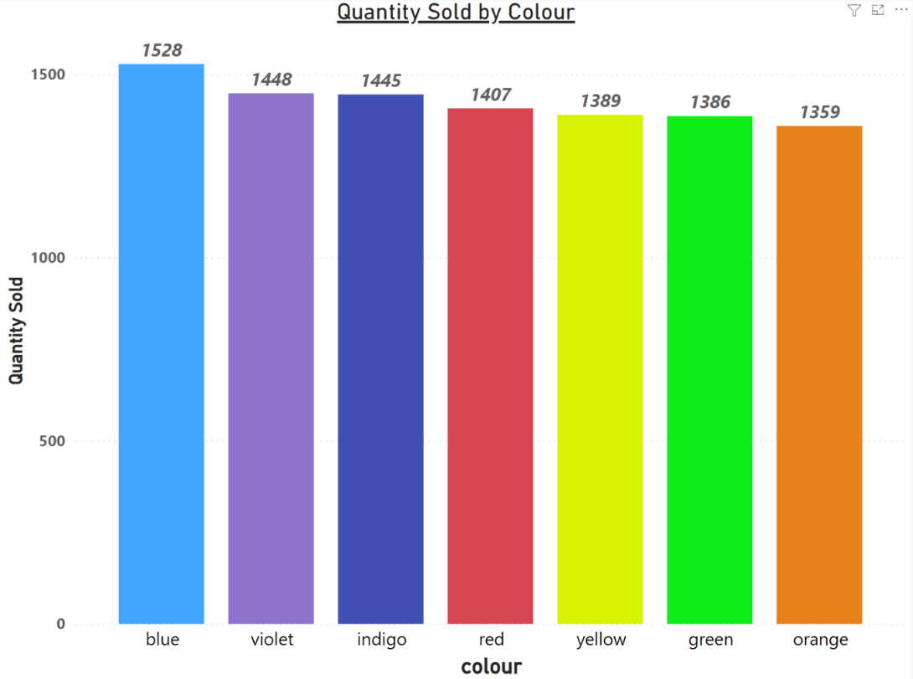

This simple bar graph represents the total quantity of products sold by their respective color. For example, the total number of blue-colored products sold so far is 1528. Moreover, the popularity of the color is directly proportionate to the quantity sold by color – the greater the quantity sold, the more popular the color. This bar graph will allow the purchasing manager to derive the quantity of products to purchase based on the popularity of each color from the suppliers. This will also allow the inventory planner to plan out the inventory space for each color before the next batch of supply comes in, ensuring there is sufficient supply for each color – more inventory space is given to more popular colors.

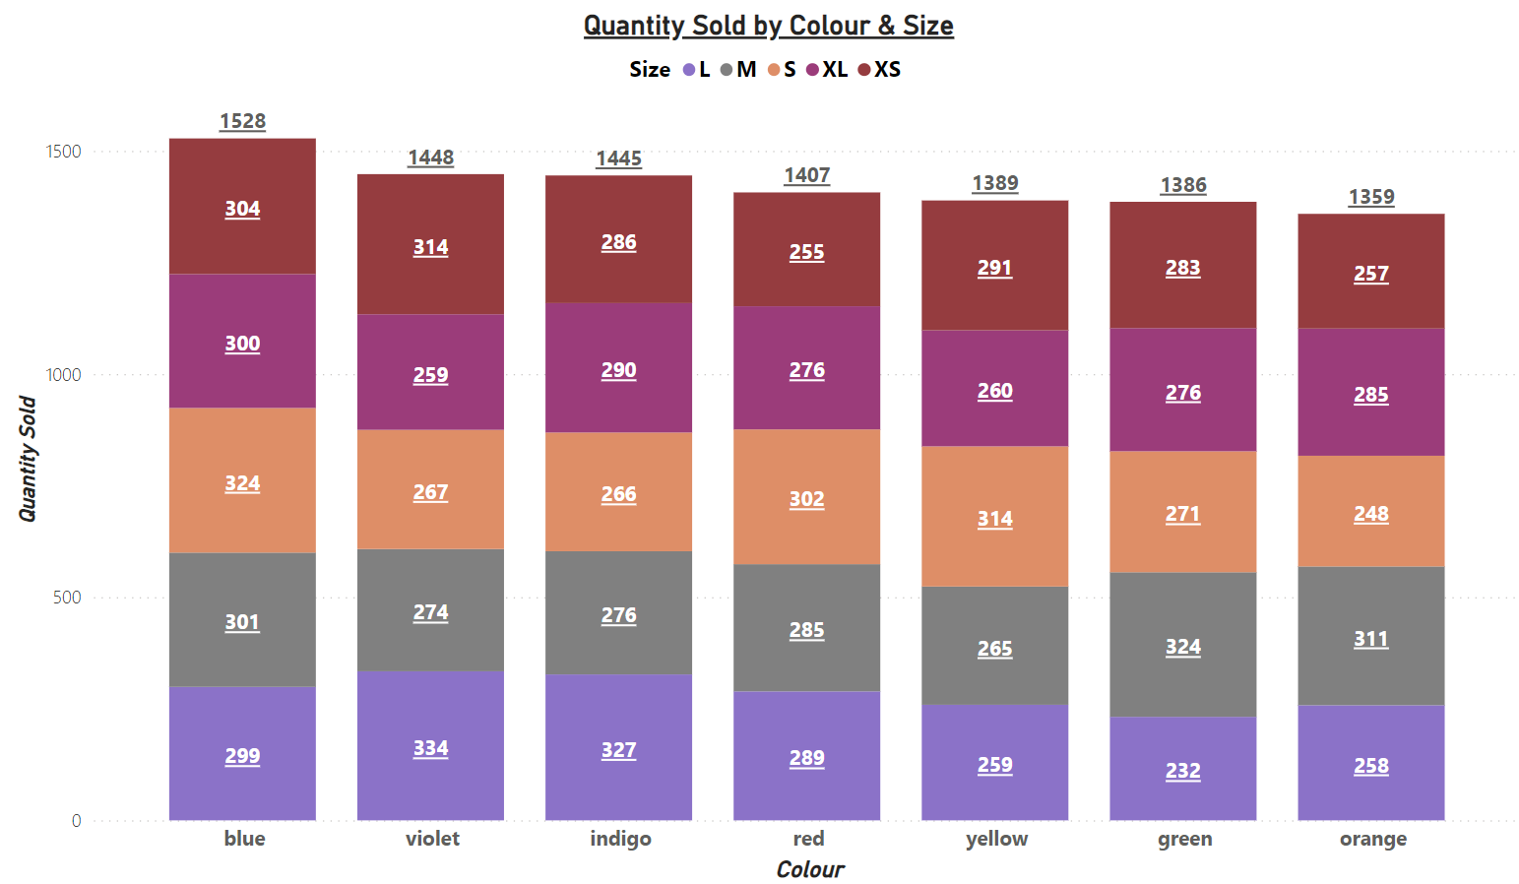

This stacked column graph represents the total quantity sold by color, and it is further specified by representing the quantity of items sold by each size for each of the 7 colors respectively. With this, the purchasing manager/inventory planner will be able to determine the popularity of the colors based on the total quantity sold by colors first, and afterwards, derive which sizes for each color are the highest in demand. This will allow the purchasing manager to plan out the quantity of products based on color and size accordingly to meet customers’ demands. Similarly, the graph will also assist the inventory manager to determine the inventory level given to products of the different colors and its specific sizes - the higher the demand of the color and its specific size is, the higher the inventory level respectively.

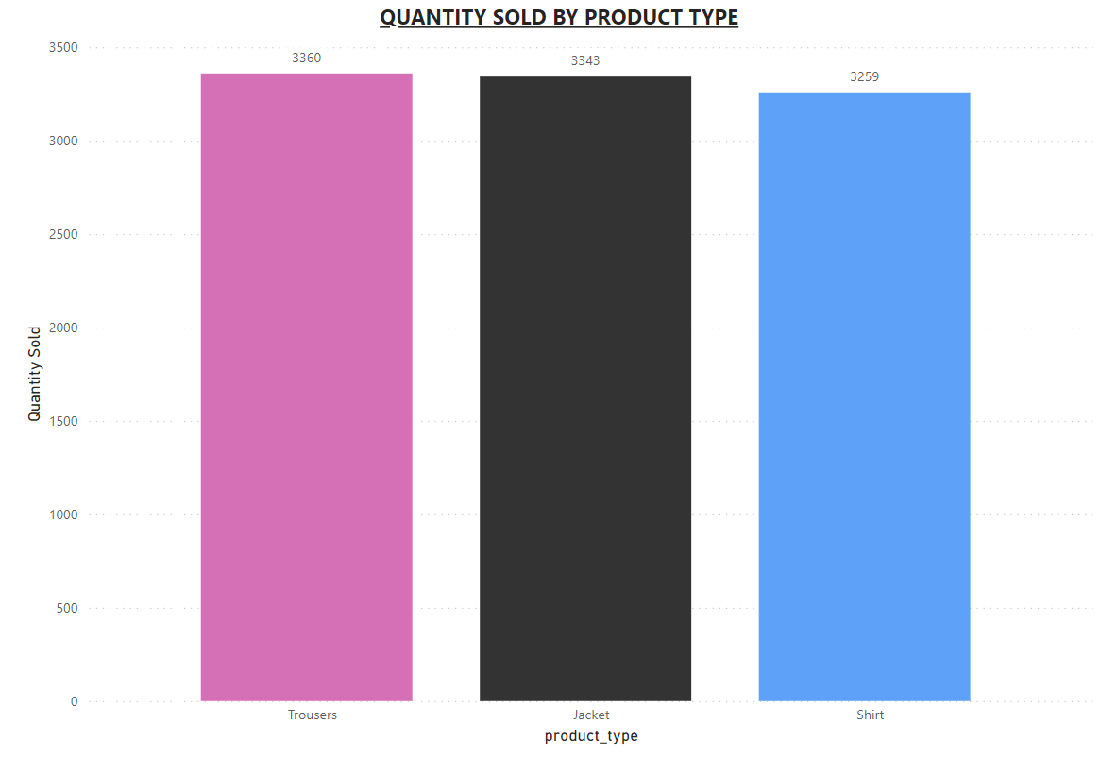

This bar graph represents the total quantity of products Aurray has sold during the 10-month operation period based on the type of products – Trousers, Jacket, Shirt. The purchasing manager/inventory planner can make use of this graph to determine which product type has the highest sales volume based on the total quantity sold for each product type, with Trousers having the highest number of sales as it has the highest quantity sold at 3360. This can help the purchasing manager to decide which product type to purchase more of to increase sale quantity. This can also help the inventory planner to plan out inventory levels and space according to sales volume/quantity of each product type – the higher the sales quantity for each product type, the higher the demand for it, the greater the inventory level & space that should be given.

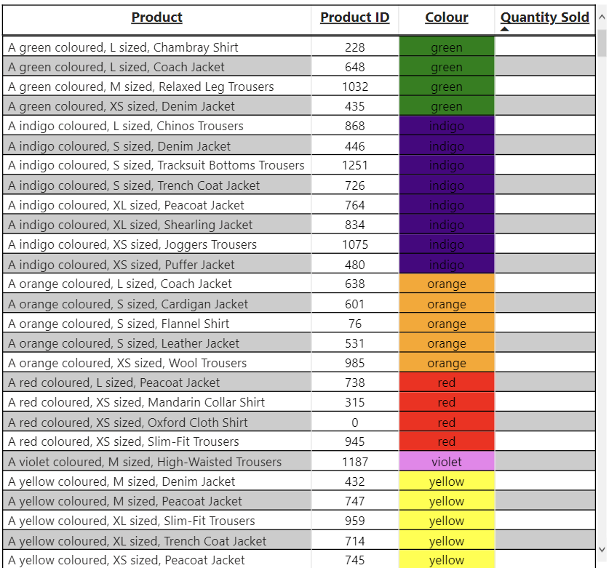

This table essentially represents the least popular items sold during the 10-month operation period, as the empty spaces in the Quantity Sold technically represent a ‘0’, showing that no items have been sold at all. The purchasing manager and inventory planner will be able to clearly identify the specific products that have not been sold in the table above, and the table is further complemented with the product’s product ID, making it easier for the purchasing manager/inventory planner to identify the product that has nothing sold in the database.

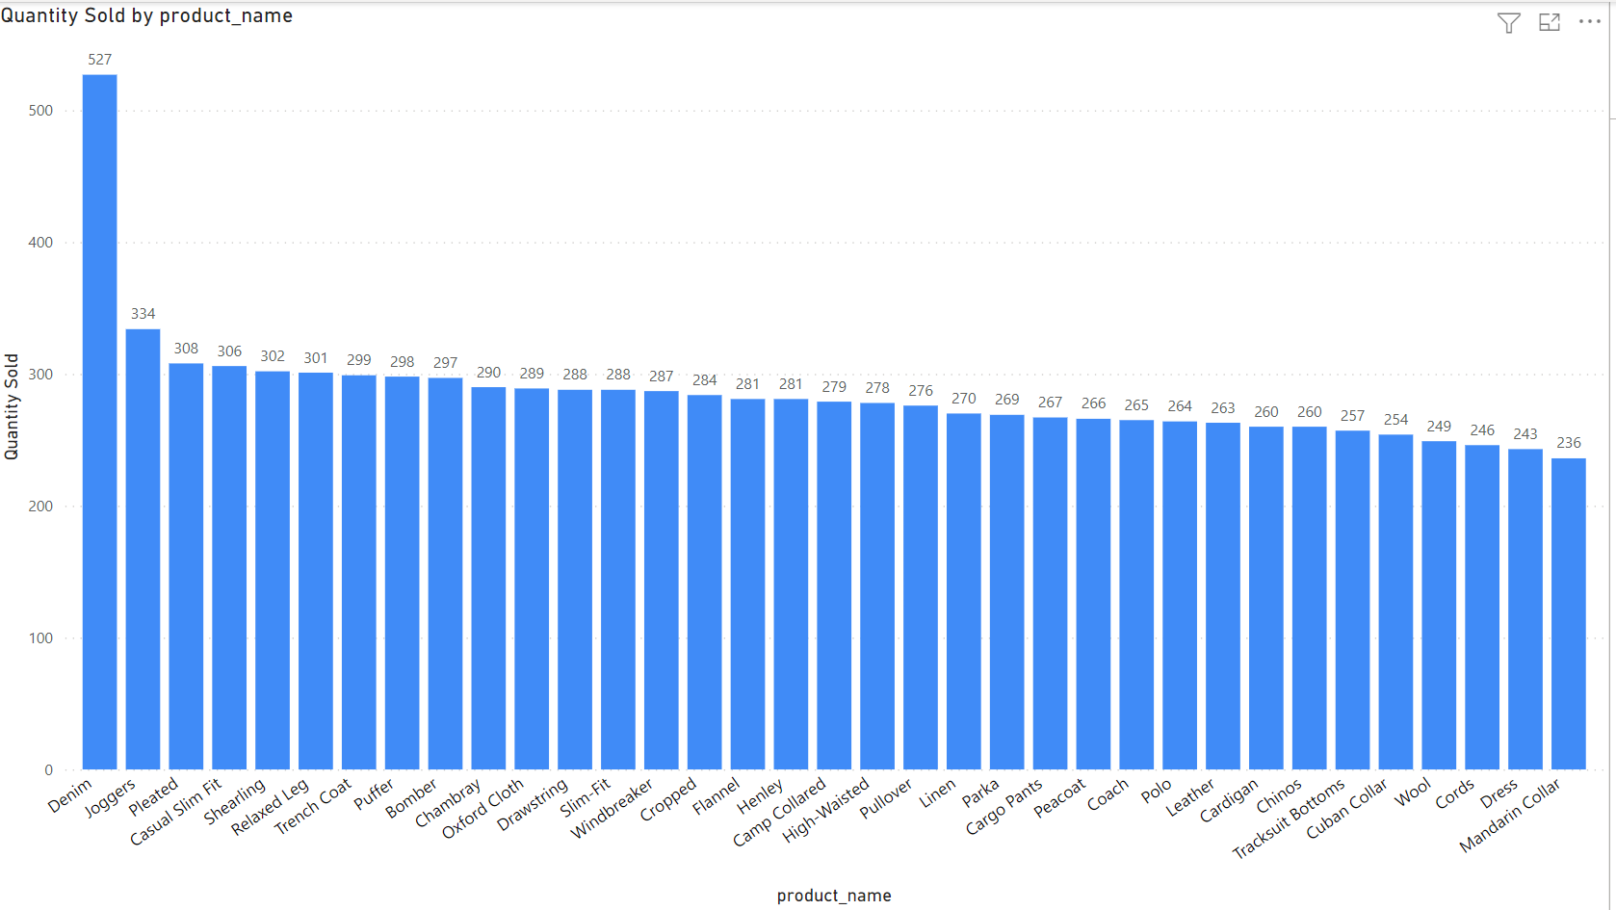

This simple column chart represents the total quantity of items sold based on the product name. The purchasing manager & inventory planner will be able to determine which product name is the highest in demand, as well as being able to determine the quantity that has been sold for each product name, allowing the purchasing manager and inventory planner to determine the quantity that is required to be purchased and managing the inventory levels respectively.

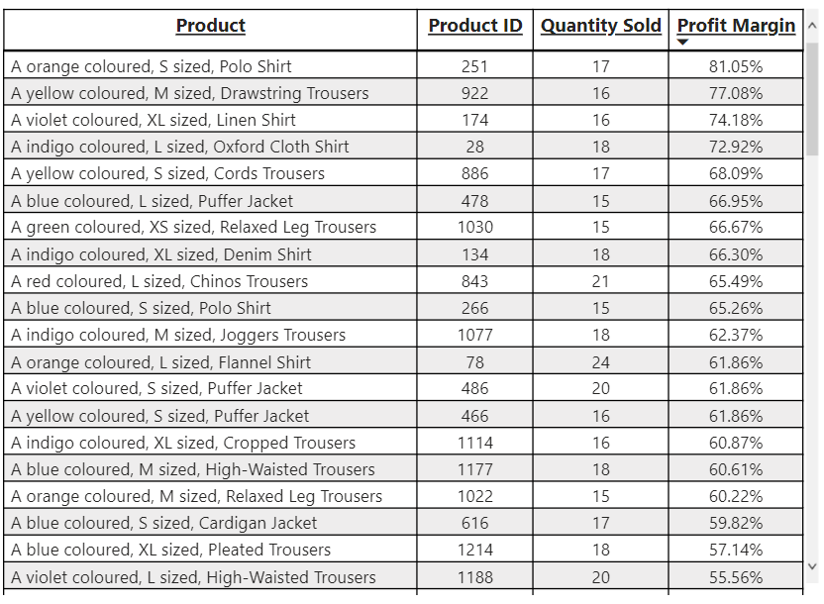

***Dashboard***

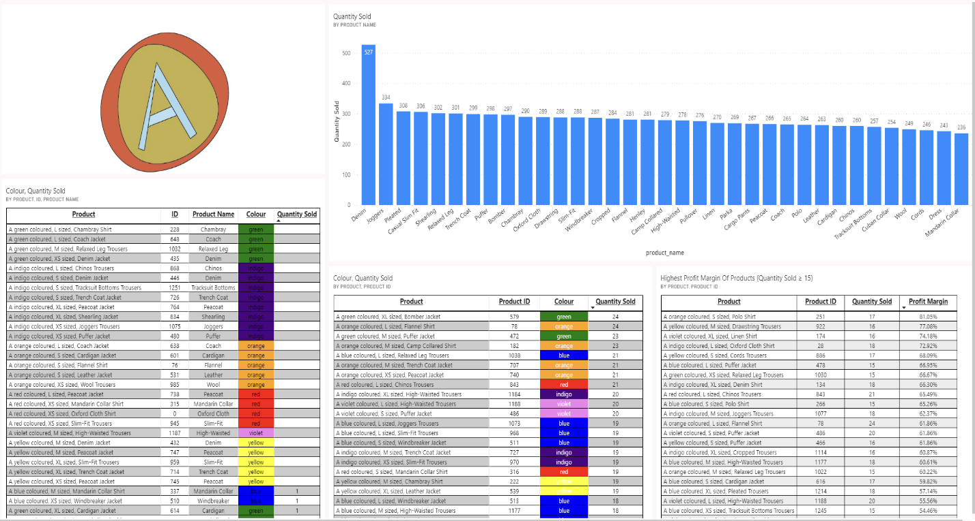***Dashboard Breakdown***

First and foremost, as the purchasing manager, my ultimate job responsibility is to ensure that I purchase sufficient resources for Aurray to fulfil the customers’ orders. And as an inventory planner, I am required to work closely with the purchasing manager to determine the quantity of products needed to be purchased. This dashboard created will allow the purchasing manager/inventory planner to make the most suitable decision when it comes to determining inventory levels and quantity purchasing.

Looking from left to right...

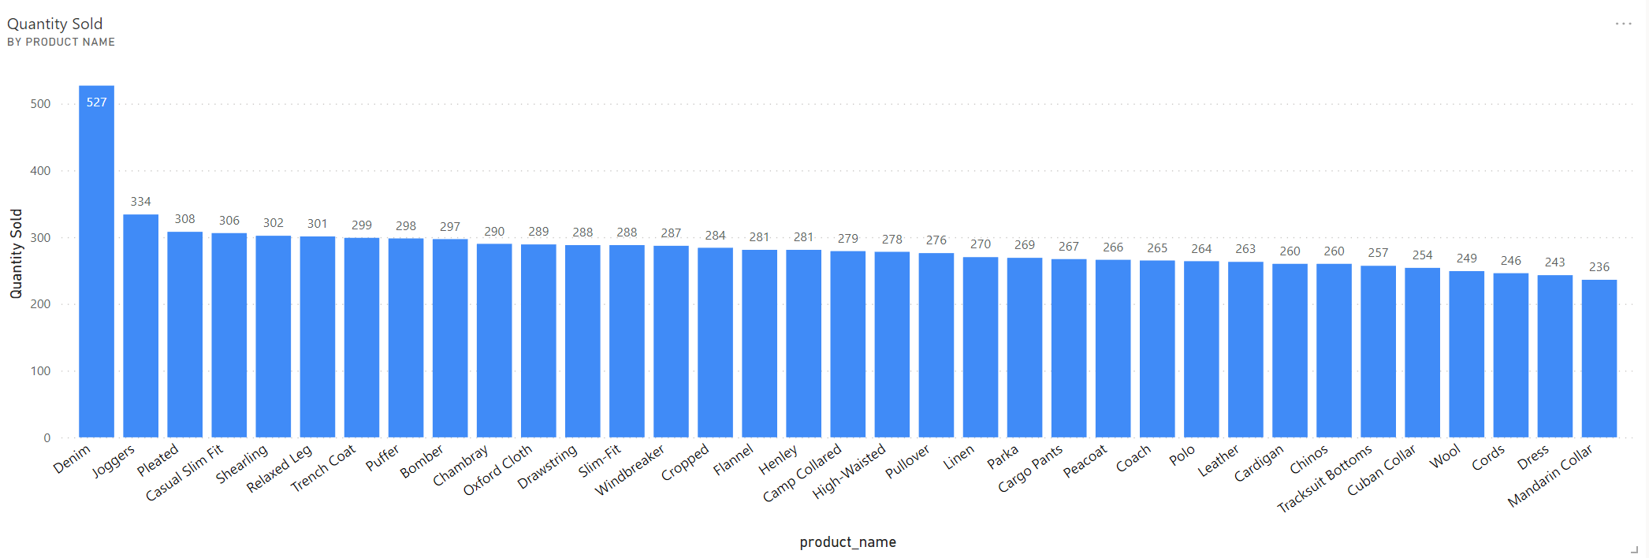The visual in the first tile represents the total sales quantity for each product name during the 10-month operation period. From the visual, both the purchasing manager and the inventory planner will be able to determine the product name that is highest in demand, which in this case is Denim, having the highest sales quantity at 527. Earlier on, an assumption was made, which was that products under the same product name are distributed by only 1 supplier. (Example: Denim Products is only distributed by 1 supplier) With this information in hand, the inventory planner will be able to make adjustments to the inventory space and level for each product name. Therefore, the inventory planner will work closely with the **Warehouse Management Team** to plan out the inventory space based on the product names, with the product name with the higher sales quantity having a higher inventory level, at the same time, having more inventory space inside the warehouse.

As for the purchasing manager, the purchasing manager will be able to determine and predict the estimated number of items to purchase during the next recontract, ensuring that there is just the right number of products purchased under the same product name. For example, as there are some product names with low sales, the purchasing manager can decide whether or not to purchase fewer of these items to minimize losses for Aurray. Besides this, the purchasing manager can decide on which supplier to request more products from based on the quantity sold by product name. For example, as Denim has sold the most products, the purchasing manager can contact and request the suppliers distributing Denim products to send more Denim products as it is a fast-moving product name.

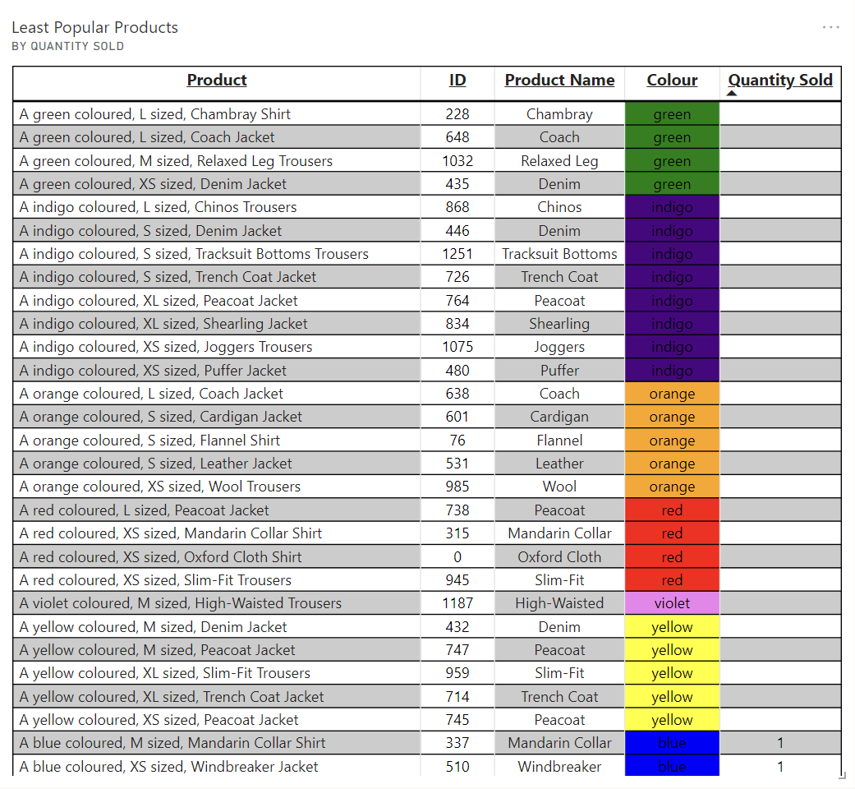

Next, after deciding on inventory levels and space for each product name, as well as the quantity purchasing of different product names, the inventory planner & purchasing manager will proceed to view this table. This table is essentially a table that represents the least popular products, as the empty spaces in the ‘Quantity Sold’ show that there are no items sold for that particular product. With this table, the inventory planner will be able to determine the specific product that does not need an increase in inventory space and level, as products that have not been sold throughout the 10-month operation period, showing that it is an extremely slow-moving product. With the visual, the inventory planner can also inform the purchasing manager to inform the suppliers to reduce the supply intake of the products that are not selling, minimizing unnecessary inventory space being occupied.

The purchasing manager will be able to determine the specific products that are not selling well, which in this case are products that do not have a numeric value in the quantity sold, essentially representing ‘0’. The purchasing manager can then proceed to inform suppliers to stop the supply of these specific products, or replace these items with another product that could potentially sell better during the recontract, ultimately to minimize losses as purchasing products requires using Aurray’s finances. Besides this, the purchasing manager can also work closely with the **Marketing Manager,** convincing the marketing manager to try their best to promote the slow-moving products by possibly changing the selling price of these slow-moving products, or offering huge discounts to sell these slow-moving products.

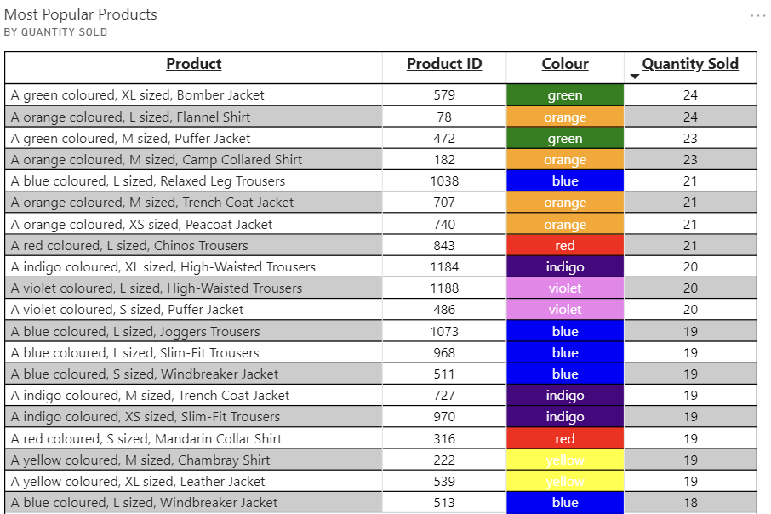

Moving on, this tile in the dashboard represents the most popular products that have been sold during the 10-month operation period of Aurray. In this table, the table shows the Top 20 most sold products according to the quantity sold, with the Green Colored XL Sized Bomber Jacket being the most salable, selling a total of 24 of them. The table is also further complemented with the Product ID, allowing the inventory planner to easily search for the specific product in the database. This essentially gives the inventory planner and the purchasing manager a rough idea on which are the most popular product Aurray has sold so far. With this table, the inventory planner will be able to determine the specific products to increase inventory space and levels based on the product popularity, working closely with the **Warehouse Management Team.** The inventory planner will also be able to inform the purchasing manager on the top 20 most popular products, requesting the purchasing manager to increase supplies for the top 20 most popular products.

On the other hand, the purchasing manager will be able to determine the top 20 most popular products based on the table shown in the tile, showing the quantity sold by descending order. Therefore, the purchasing manager will be able to contact the suppliers of these products that are selling the best, requesting and purchasing more of these 20 most popular products to increase sales, increasing potential sales revenue as the business continues in the long run. Furthermore, after knowing the top 20 most popular products, the purchasing manager can also contact the **Marketing Manager** to further promote these products, increasing sales potential.

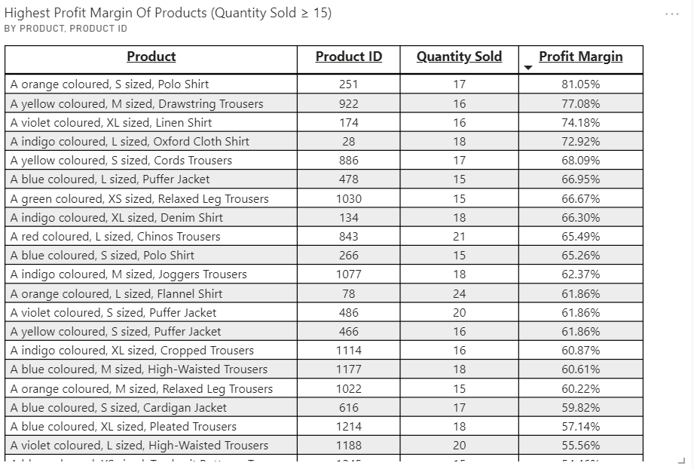

Finally, this tile essentially represents the specific products that have the highest profit margin during Aurray’s 10-month operation duration. The table is filtered in such a way that products with a quantity sold of 15 or more will only be shown on the table. By doing so, this ensures reliability of the data shown. By looking at this table, the purchasing manager & inventory planner will be able to determine the products that have the highest profit margin. Ultimately, every company exists to generate profits. Hence, the purchasing manager will be able to find out the specific products that have a high profit margin. And so, the purchasing manager can then contact the suppliers of these specific products with a high profit margin of 60% and above, to purchase and supply more of these products, which will allow Aurray to generate greater profits in the long run. The purchasing manager can also contact the **Marketing Manager** to promote these products with high profit margins to increase sales revenue, maximizing potential profits.

The inventory planner can also make use of this table to determine the specific products with high profit margins. And hence, this will allow the purchasing manager to determine and predict which products to increase inventory space and levels for based on the profit margin of the products.

**5.Logistics manager (Bharathkumar Vishwanath)**

The logistics manager is responsible for warehouse operations and delivery to customers. His order fulfilment staff have to carry out their work efficiently. To maintain a very positive image for the company, the Logistics Manager will strive to ensure that when an order is placed, this order is fulfilled at the fastest possible time. However, when making deliveries for orders, this person will help to plan out the delivery routes so that the deliveries can be made at the quickest time with the least transportation cost.

What data is he interested in:

-The list of customer orders that need to be packed for the day to reach customers on their chosen delivery date (longer time needed for delivery to customers in states further away from warehouse)-order file

-Pick list and assign packers to pack-order details file

- Number of items that are returned due to any reasons(eg. Wrong delivery, defective item)

-Best selling items (to put near the door of the warehouse), faster to pick and pack for delivery

-Least popular items (to put at back of warehouse)

-Number of orders delivered on time

-Arranging customers state wise for cost effective transportation

Empathize:

I have to make sure that products are delivered on time and customers are satisfied. I also have to notify superiors of the products that need more manufacturing and supply as it has a high number of broken items.

Prototype:

Create dashboards and power bi reports

Role presentation:

* Do the job properly to get salary

**Exploratory questions:**

-What are the best-selling products to put near the warehouse entrance?

-What is the number of delivery staff required to fulfil month-wise delivery orders?

- Which region has the highest number of orders to negotiate transport vendors?

-How to arrange products according to order list?

-What are all the orders from each region to print out order list?

-Which customer has the earliest delivery date to assign pick-up staff?

-For the best-selling item, which is the best-selling color to put near the warehouse?

-For the best-selling item, which is the best-selling size to put near the warehouse?

-From looking at location, how to assign the job to minimize transportation costs

-From comparing stock availability with customer order list, highlighting purchase manager on

Reorder level.

**Actionable statement:**

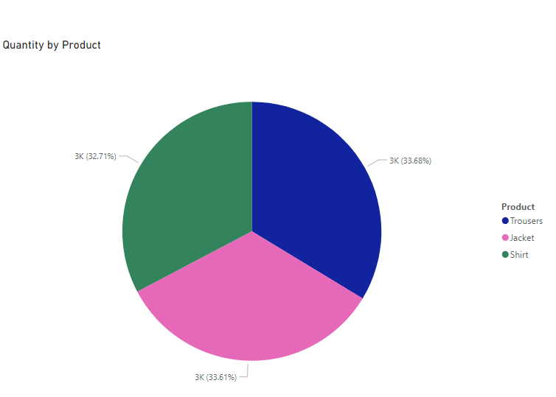

As a logistics manager, I looked at order details and identified which product has the highest volume of orders. This pie chart shows that the Trousers needs more warehouse space than both the shirt and jacket. Data shows order for trousers takes up 33.68% of overall order quantity, followed by jackets at 33.61% and then shirts at 32.71%. From analyzing the data, I will assign more pick-up staff for handling the trousers followed by jackets then shirts. This will facilitate picking and packing of order lists in the most productive manner. I will arrange for the trousers to be the nearest to the warehouse entrance. This will ease the work of staff as they will not have to move the products from one side of the warehouse to another. This will also speed up delivery time, increasing efficiency.

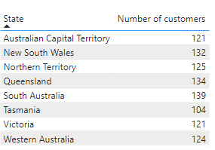

I have identified the customer data state-wise. Using it, I intend to negotiate better deals with transport and logistic vendors. The greatest number of customers are found in South Australia followed by Queensland, New South Wales, Northern Territory, Western Australia, Victoria, Australian Capital Territory and at last Tasmania. The main aim is to ensure an efficient and cost-effective distribution network. Thus, we ensure timely and quick deliveries leading to better customer satisfaction and delight. This would lead to better customer retention, repeat order and new customers due to ‘word mouth publicity’.

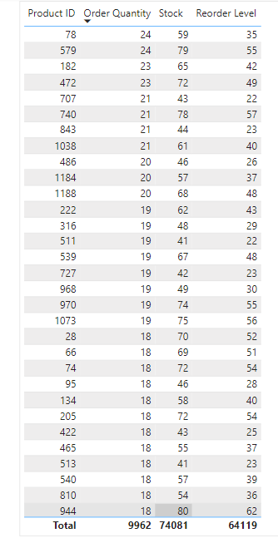

This table is organized to show products in descending order of demand. Thus, we are able to select better storage locations for high demand items. Although we previously reviewed the best-selling items, we never reviewed the best-selling sub- categories such as material, colour and sizes. As a logistics manager, it is important to analyze these items specifically in sales to allocate warehouse space for those specific items. This table also shows analysis of stock availabilities and its needed reorder level. This is to provide the purchasing manager with the necessary reordering quantities on time. The reorder level is arranged top to bottom based on order quantity as the best-selling products are the ones that require more priority on reordering as the demand for it will be higher.

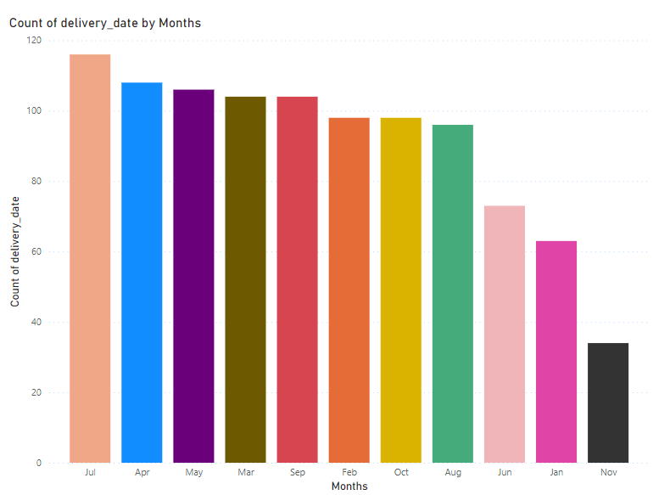

It is pertinent to look at seasonal demand from customers. This helps to identify the peak periods and demand, thus aiding in planning warehouse operations. During months such as November and January, when order and demand is very low, I can give the majority of employees time off so they can come back to work with more drive and focus during peak months such as July, April and May. This allows me to maintain employee satisfaction while also maintaining customer satisfaction. Thus, I can maintain and strengthen manpower in the warehouse.

**Dashboard:**

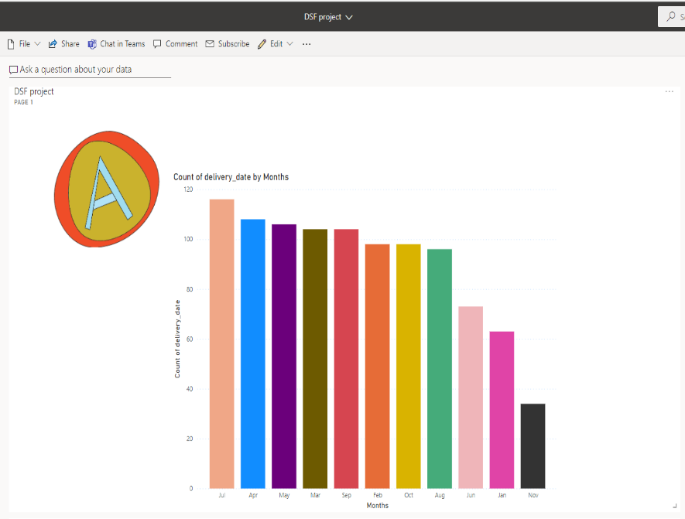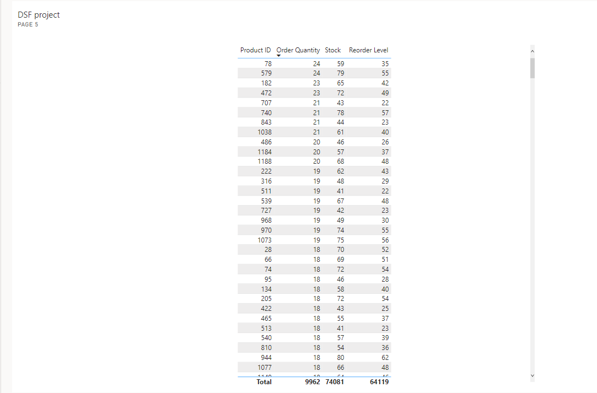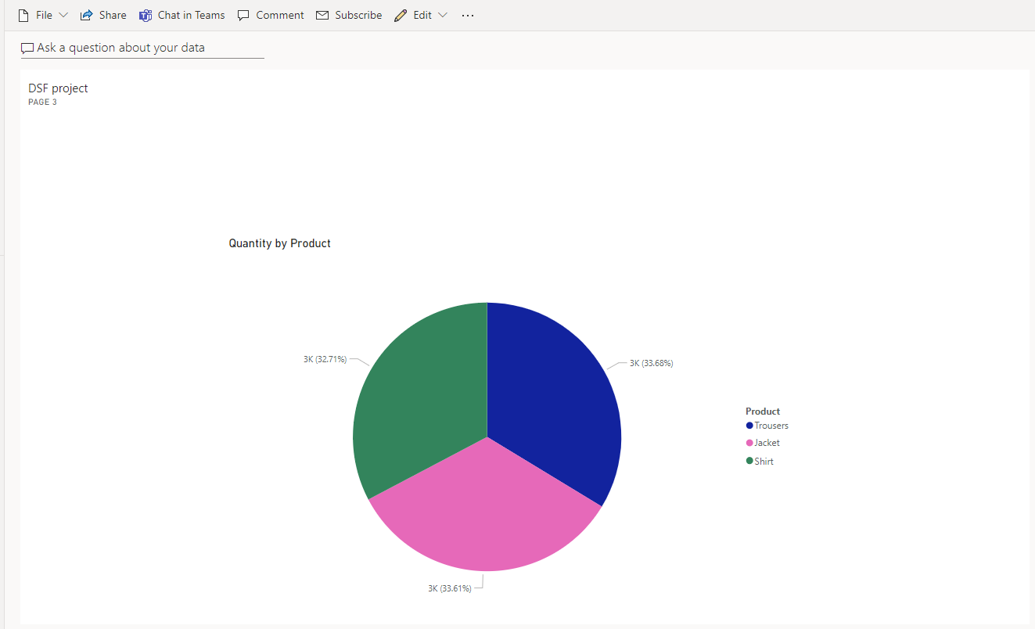

The dashboards shown consist of a compilation of all the visuals to emphasize all the solutions provided to have more efficient warehouse operations and faster deliveries to fulfil my role as a logistics manager, boosting Aurray’s overall productivity and profit gains.

**Group Reflection**

**Challenges faced:**

As a group, it was difficult to set up meeting times in between our busy schedules, which resulted in some confusion within the group about our roles and what we had to do. During our group discussions, it was especially difficult to determine which data we should use for our individual stakeholders.

We also faced some technical difficulties such as the date hierarchy for **orders** is not autoloaded in Power BI and having trouble putting the image of the company logo into the dashboard.

We also did not communicate as well as we should have, which resulted in only certain people knowing certain information while the rest were kept in the dark. This caused a lot of confusion, in which some group members did not know what to do.

**Improvements:**

We should have planned our schedule properly and met up for discussion more often, in order to be clearer about the task we needed to do.

We should have done this group project earlier and not rushing a few days before the date line. This could have been due to our poor scheduling and procrastination.

**Individual Reflection**

**Ang Yi Yang:**

What I have learnt from this module:

Overall, I have learnt more about how to think as a stakeholder of a company as well as a data analyst, I have learnt how to analyze data based on the needs of a stakeholder through empathising with the stakeholder, defining the problems that need to be solved, prototyping by having rough sketches of visuals and testing the limits of the visuals to see what it can help the stakeholders with.

Technical skills I learnt:

I learnt how to use power bi and all its functions like creating visuals, data transformation and power bi query I also learned the functions of a dashboard that can be used to easily visualize charts and graphs in a more contained way.

**Vishwa:**

What I have learnt from this module:

I have learnt to understand and perform the role of my stakeholder through empathizing with him and putting him in my shoes. As a logistics manager I learnt to arrange my distribution service and day-to-day warehouse operations through analyzing demand for products.

Technical skills I have learnt:

I have learnt how to use power bi tools and functions. I have learnt to make dashboards, queries and visuals to help analyze Datas and solve problems faced by companies using these data. This helps me in the future when I am pursuing a job as a business analyst as I have to find solutions for company problems and find ways for company to grow and expand to make more profits through analyzing data.

**Huang Wen:**

What have you learnt from this module:

I have learnt the job scope and role a CEO plays in the company. What data and visuals do a CEO need? What information and data are useful for the CEO’s job scope? How to analyze the data required for CEO using Thinking Framework - Empathize, Define, Ideate, Prototype and Test taught in school. How to design, develop and implement dashboard(s) in answering the stakeholders’ actionable statements.

How can the acquired skills help you in future:

I acquired skills in how to analyze the data needed for my stakeholder and the use of Power BI. The use of power BI can help me to create visuals and dashboards when having a large amount of data. This is also an important and a must skill for me as I wanted to go into the data science module and work in the data science industry. Additionally, knowing how to analyze data needed for stakeholders is important as it helps me to create a visual that is suitable for my boss in future, without having unnecessary data or visuals.

**Neron Phang:**

What have you learnt from this module:

I have learnt the sales manager and the marketing manager are in charge of different sections when pushing out a product, where the sales manager comes into play right after the marketing manager. I have also learnt that the sales manager is vital in keeping the company afloat through their in-depth report on the company’s financial welfare.

The data given is important for the company as they show the performance of the company over 10 months. Additionally, methods that CEO will implement based on the visual and dashboard.

**Ryan Ma:**

What I have learnt from this module:

This module has given me the opportunity to broaden my knowledge of the use of Power BI and the various functions that it has to offer. Besides this, the module tutorials proved useful in assisting me while I was creating the visuals and dashboard for my assignment. The module tutorials were especially applicable and fun to do, as it was insightful and interesting to find out how I am able to represent my data in different ways, as well as learning how to model, transform, and create relationships using the data provided for us. Needless to say, this module has also made me apply immense critical thinking when it came to completing my assignments, trying my utmost best to analyze the needs of my stakeholders adequately, applying the design thinking framework as well. This module has certainly been a memorable experience for me, igniting my passion for the DSF route in the future.